|  |  |  |  |  |  |  |  |  |  |  |  |  |  |  |  |  |  |  |  |  |  |  |  |  |  |  |  |
| --- | --- | --- | --- | --- | --- | --- | --- | --- | --- | --- | --- | --- | --- | --- | --- | --- | --- | --- | --- | --- | --- | --- | --- | --- | --- | --- | --- |
| Excell-On Services    |  |  |  | | --- | --- | --- | | **Supervisor:** | *Ngô Văn Thuận* | | | **Semester:** | *III* | | | **Batch No:** | *T1.2112.E0* | | | **Group No:** | *II* | | | **Order:** | **Full name** | **Roll No.** | | *1.* | *Nguyễn Tuấn Lộc* | *Student1350801* | | *2.* | *Hứa Lê Quang* | *Student1350321* | | *3.* | *Trần Nam Trung* | *Student1350800* | | *4.* | *Nguyễn Lê Thanh Tùng* | *Student1350318* | |
| ***Month****: April* ***Year****:  2023* |
| This is to certify that   |  |  | | --- | --- | | **Mr.** | **Nguyễn Tuấn Lộc** | | **Mr.** | **Hứa Lê Quang** | | **Mr.** | **Trần Nam Trung** | | **Mr.** | **Nguyễn Lê Thanh Tùng** | | Have successfully Designed & Developed | |  |  |  | |  | | | |  |   Submitted by:   |  | | --- | | **Mr. NGO VAN THUAN** |   Date Of Issue:   |  |  | | --- | --- | |  |  |   Authorized Signature: |

**REVIEW 1 ................................................................................................................. 3**

**Introduce .......................................................................................................... 3**

**Synosis ............................................................................................................. 3**

**Problem definition ........................................................................................... 3**

**Requirement specification .............................................................................. 3**

**Non-Functional requirement........................................................................... 11**

**System requirement ........................................................................................ 11**

**Task sheet review 1 ......................................................................................... 12**

**REVIEW 2 ................................................................................................................. 13**

**Architecture & Design of the Project ............................................................. 13**

**Algorithms-Data flowchart .............................................................................. 14**

**Use case Diagram............................................................................................ 16**

**Entity-Relationship Diagrams......................................................................... 17**

**Task sheet review 2 ......................................................................................... 18**

**REVIEW 3 ................................................................................................................. 19**

**Site map ........................................................................................................... 19**

**GUI design ....................................................................................................... 21**

**Client GUI & code .................................................................................... 21**

**Admin GUI & code ................................................................................... 39**

**Task sheet preview 3 ....................................................................................... 57**

# REVIEW 1

* **Introduction**

In the process of graduation, we have received a lot of help, suggestions, and enthusiastic advice from our teachers, family and friends. We sincerely thank Aptech Education for bringing the experience as well as practical skills in the project to bring us.

We would like to thank Mr Ngo Van Thuan, a teacher of FPT Aptech for always being dedicated and professional. Without the knowledge and experience of her superior, this project will not succeed.

And we sincerely thank the families of our team members for their great enthusiasm and support during the project.

This project is also successful thanks to the cooperation of the team members. Thank you.

* **Synosis:**

Excell-on Consulting Services (ECS) helps organizations develop innovative business and commerce strategies and solutions. These solutions allow their (organizations, say clients of Excell-on Consulting Services) customers to capitalize on new technologies to create innovative products and services for the economy. Their consulting team stays focused on defining, optimizing, and aligning their client’s business and IT strategies.

* **Problem Definition:**

Excell-on has segregated themselves into various branches based on the various services that they offer to their clients, so as to meet the requirements of organizations i.e., of their clients. The various branches that the Excell-on had segregated is as follows:

1. In-bound Services (The In-bound service is a service in which one can only receive the calls from the customers. These call centers provide 24 hours service to all customers. The primary goal of these call centers are to receive product orders, help customers both technically and non-technically, to find dealer location.)
   * Technical Support
   * Customer Service
2. Out-bound Services (The Out-bound service is a service in which the employees of Excell-on call the customers for product promotions, for checking with the customer satisfaction on the services they provide, and for the telemarketing. Outbound Call Centers depends on the technological solutions, extensive experience, quality assurance programs and commitment to customer service excellence that further ensures maximum results from the direct marketing efforts for its success.)
3. Tele Marketing Services (The Tele Marketing service is a service which is purely for the promotion of marketing or sales of the products and services.)

* **Requirement Specification**

**I. Customer's Requirement Specifications**

As the Internet and the web being the growth engines of the new millennium, the management had decided to maintain the details of their services and that of their clients along with the services that they (clients of Excell-on) prefer, payment details. So they want an online application to be introduced into their system through which they can keep track of the services they provide, their clients, type of service that their client had preferred, and the products and the procedures of their clients and the details of the customers, and the call logs.

So they had approached us in order to help them by creating a web application for them meeting their requirements. The application should hold the following functionalities.

**Non-Financial:**

1. The details of the services offered are to be maintained.
2. The different department details are to be maintained. The different departments that Excell-on has is as follows
   * HR Management
   * Administration
   * Service
   * Training
   * Internet Security (It will take care of any technical related issues and problems like PC of an employee is hanged, PC of an employee is not getting started, One of the software application is not running properly, installing and uninstalling software, etc.)
   * Auditors
3. The details of the employees are to be maintained based on the designation and the services (like out-bound, in-bound, etc.)
4. The details of the charges levied for each service are to be maintained.
5. The details of the clients are to be maintained.
6. The details of the services that their clients preferred are to be maintained.
7. The details of the products and services that their clients offer (like if the client is a manufacturer of refrigerators, then the details of the different type of refrigerator they manufacture are to be maintained, and if the client is the internet service provider, then the details like the various type of the services that they offer, and they want Excell-on to promote the sales services for that company using the in-bound or out-bound services, then these details are to be maintained, etc.) are to be maintained.
8. Based on the charges levied for a service, the total charges for the clients are to be calculated based on the services that the client prefers.
9. The details of the payments as received by the client are to be maintained.
10. The reports for the late payments, payments, clients, employees based on the services, for a particular duration are to be generated

**Financial:**

The charges for the different services that they offer keep on varying based on the services preferred by their clients. The charge structure for the services that the Excell-on offers is as follows.

|  |  |  |
| --- | --- | --- |
| **Sr. No**. | **Service** | **Charges (per day per employee)** |
| 1 | In-bound | 4500$ |
| 2 | Out-bound | 6000$ |
| 3 | Tele Marketing | 5500$ |

1. **Home Page:**

**a/ Header – All Page for client will extend the header:**

* + On the top will show information contact ( telephone, time open, email )
  + Logo on the left side
  + On the right side of navbar will show All Service Categories includes 4 Tab:

+ Home

+ Services ( Category ) – will have child menu show 3 Category

+ About Us

+ Contact Us

Also has an icon show Social Media ( Facebook, Twitter, Insta… ), User can click will link to our Page

**b/ Body:**

* + First section is a Slider, will show all Services, has a button “Read More” will link to the detail Services
  + Section About Us ( Short Description ) and will have a button “Explore more” can link to About Us Page
  + Section Our Services will show all categories
  + Section Why Choose us will describe our power description
  + Section show All team members- Section show Testimonial

**c/ Footer – All Page for client will extend the Footer:**

* + Show all information of company ( branch address, all services, Quick links
  + At the end of the footer, will have a bar, on the left will show Copyright info, on the right will show Developed info.

1. **About us Page:** 
   * This page will show the history of our company, when the organization started , how, where etc…
   * Will have a section will show Chairman’s profile – the details about our chairman company
   * Will have a section show board of directors : Details about the board members
2. **Services Page ( Category ):**

In this page, will has sections about services of company, and every section will show child Services

1. **Our network – ( Location ):**

o North region

o West region

o East region

o South region

**It should provide the details of Star branches (address /contact details/ contact person in the various regions as above**

1. **Admin Clients Page:**

o Name of client

o Services available

o Staff assigned

1. **Login:** 
   * + Website should provide login for the employees and customer. Customer can register and login like normal, but in admin side can not register.
     + **The employees will have the restricted access to the website content as per their role. E.g. the normal staff can see the personal details of the other staff, where all have posted etc. But they cannot access the areas like editing the services offered, staff details, vacancy posting etc.**
2. **Testimonials**

- This page will display testimonials from customers, will display information and the customer compliments.

1. **Site map**
2. **Contact us**

- This page will display the contact information, have form input send request, google map iframe….

1. **Admin Details Employee Page:**
   * Will Show Employee Name
   * Will Show Employee address
   * Will Show Employee contact number
   * Will Show Department
   * Will Show Role
   * Will Show Grade
   * Will Show Client
2. **Users with admin privileges can**

**12.1 Admin Authorize: We will have 4 permissions:**

+ Super Administrator – level 1 ( Manage all Website )

+ Department Administrator – level 2 ( Mange locations depend on their role)

**a/ Super Administrator – level 1:**

+ Can CRUD new general administrator ( level 2 )

**b/ General Administrator – level 2:**

+ Can CRUD new administrator ( level 3 )

+ Can CRUD all Locations ( Branches )

+ Can change permissions of user ( Level 3, Level 4 )

**12.2 Admin Authorize Details**

**a/ Add/update/delete/edit the details of the employees.**

- Each employee belongs only to the management of admin’s location

**a.1/ Manager**

+ R1: Login page (manager account must be registered by super admin and enabled permission to control application), input username and password.

+ R2: Login failed, show error message box for wrong username and password, still stay at login page, do nothing.

+ R3: Login succeeded, show login success message box.

+ R4: Route to page of function of admin manager.

**a.2/ Team leader**

+ R1: Login page (leader account must be registered by Manager and enabled permission to control application), input username and password.

+ R2: Login failed, show error message box for wrong username and password, still stay at login page, do nothing.

+ R3: Login succeeded, show login success message box.

+ R4: Route to page of functional team leader.

**a.3/ Employee**

+ R1: Login page (manager account must be registered by Manager, only permission to read information only), input username and password.

+ R2: Login failed, show error message box for wrong username and password, still stay at login page, do nothing.

+ R3: Login succeeded, show login success message box.

+ R4: Route to page where show personal information.

**b/ Add/update/delete/edit services offered**

All routes same **(a)** and includes:

+ Each admin is only allowed to manage one location

+ Each service will belong to one location

+ Admin level 2 is allowed to add/update/delete/edit new Services at their branch  **c/ Add/update/delete/edit employee details**

All routes same **(a)** and includes:

+ Each employee belongs only to the management of the admin’s location

+ Each admin is only allowed to manage one location

+ Admin level 2 is allowed to add/update/delete/edit employee by admin at there location

**II. Non-functional Requirement Specifications**

* REQ-1. Good using Interface and Experience.
* REQ-2. Clean code.
* REQ-3. Try hard to improve the performance.
* REQ-4. Try limit bugs on this website

**III. System Requirement Specifications**

The Guest accessing the website for the first time can register right away or just search for a product but lack service. When they want to actually buy a product and pay for it, they need to register to become a customer then all of the service will be available.

* **Server requirements:**

- **Hardware**:

|  |  |
| --- | --- |
| Component | Requirement |
| CPU | Processor type:  Pentium III-compatible processor or faster Processor speed:  Recommended: 1.0 GHz or faster |
| OS | All OS(Windows ,Linux ,Android ,Mac OS …) |
| Memory (RAM) | RAM:  Minimum: 1 GB  Recommended: 2 GB or more  Maximum: Operating system maximum |
| Hard Drive | Free space:  Minimum: 10 MB |

- **Software**:

Component Requirement Web Browser IE 8.0 , Firefox 3.0,Chrome or Higher…..

* **Development Software:**
* Microsoft SQL server Management Studio
* Microsoft Visual Studio 2022
* **Technology:**
* ASP.Net Core API 6.0
* Entity Framework Core 6.0
* ReactJs 16 or higher

**TASK SHEET REVIEW 1**

|  |  |  |  |  |  |  |  |
| --- | --- | --- | --- | --- | --- | --- | --- |
| **Project Ref. No.:**    **eP/Advertisement**  **Portal Management** **System/01** | | **Project Title:** | **Activity Plan**  **Prepare d**  **By:** | **Date of Preparation of Activity Plan:** | | | |
| **Sr.N**  **o.** | **Task** | **Actual**  **Start**  **Date** | **Actual**  **Days** | **Team** **Mate**  **Names** | **Status** |
| 1 | Introduce | Excell-On  Services | All  member | 17/04/2023 | 1 | LE QUANG | Completed |
| 2 | Problem  Definition | 17/04/2023 | 1 | LE QUANG | Completed |
| 3 | Requirement & Non-functional requirement | 17/04/2023 | 1 | NAM TRUNG | Completed |
| 4 | Process Analyst & Task sheet review | 17/04/2023 | 1 | TUAN LOC | Completed |

# REVIEW 2

1. **Architecture & Design of the Project**

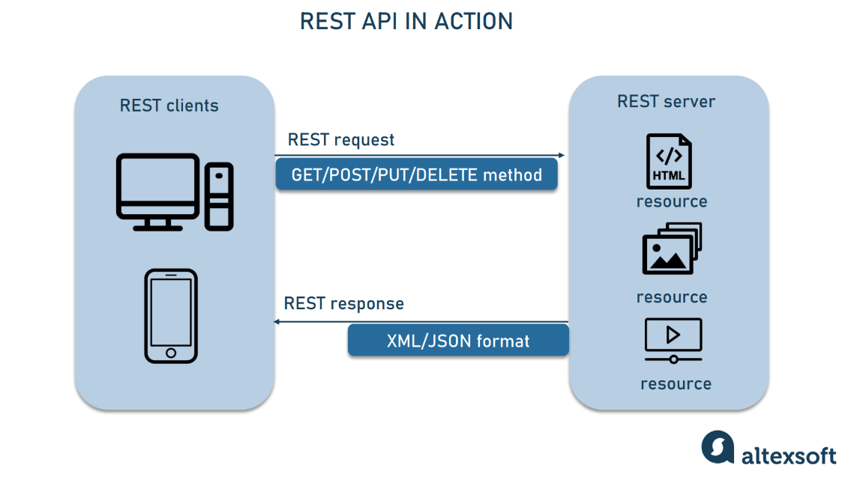

* 1. **Presentation**

Exposes interaction capabilities for the end users or applications / systems wanting to interact with it.

Interacts with the Business Logic layer.

Can interact with other applications (through their presentation layers).

* 1. **REST Client**

Can interact with other applications (through their presentation layers).

* 1. **REST Server**

Acts as a data controller, to be utilized from REST Client.

Can interact with other applications (through their presentation layers).

1. **Algorithms – Data Flowchart**

**1. Symbol generates:**

Process Decision



Start/End Input

# Database Program Flow

1. 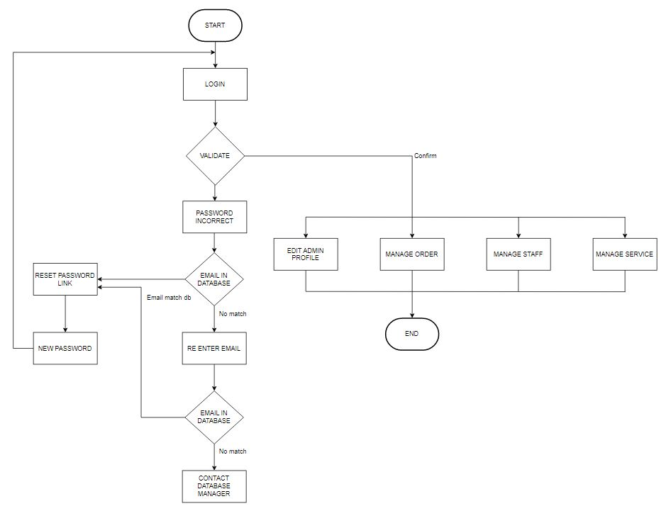**Main data flowchart for users**

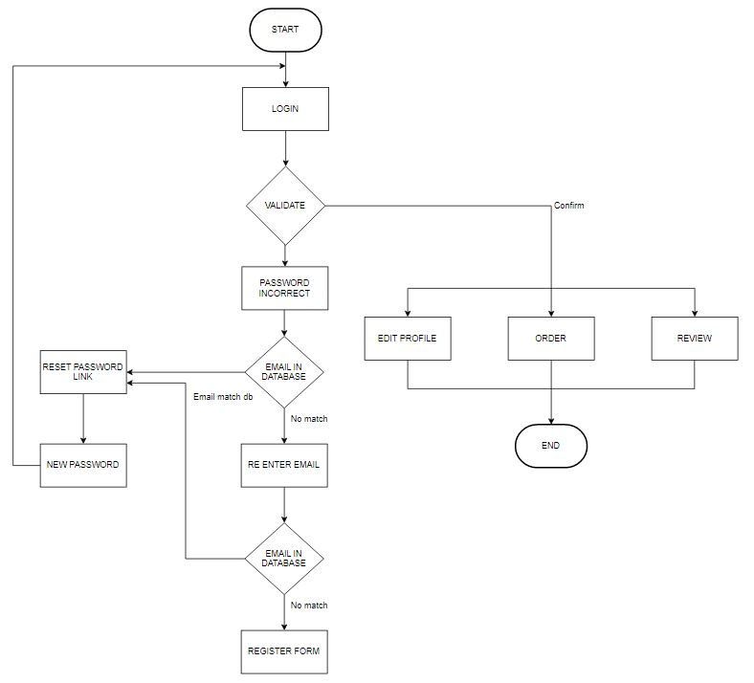

1. **Admin Flowchart**

1. **Use Case Diagram**

a/ User Authorize Use Case

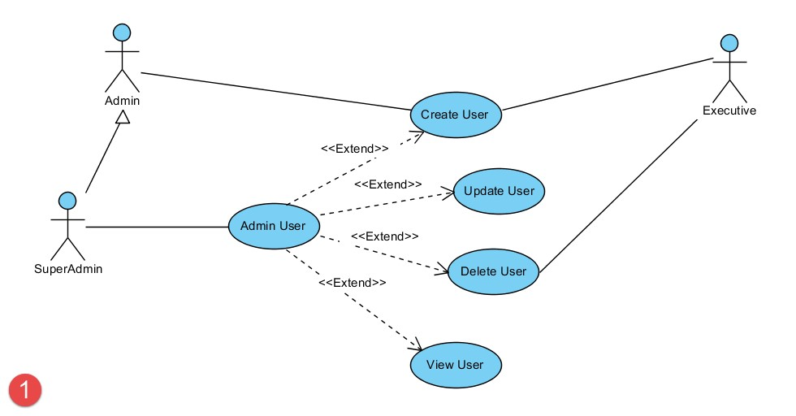

1. **Entity – Relationship Diagrams**

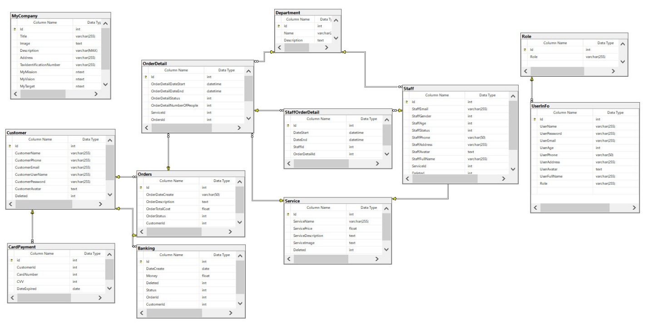

**TASK SHEET REVIEW 2**

|  |  |  |  |  |  |  |  |
| --- | --- | --- | --- | --- | --- | --- | --- |
| **Project Ref. No.:**    **eP/Advertisement**  **Portal Management** **System/01** | | **Project Title:** | **Activity**  **Plan**  **Prepared** **By:** | **Date of Preparation of Activity Plan:** | | | |
| **Sr. No.** | **Task** | **Actual**  **Start**  **Date** | **Actual**  **Day s** | **Team**  **Mate**  **Names** | **Status** |
| 1 | Architecture &  Design of Project | Star  Security  Service | All  Members | 18/04/2023 | 1 | TUAN LOC | Completed |
| 2 | Algorithms - Data Flowchart | 18/04/2023 | 1 | TUAN LOC | Completed |
| 3 | Use Case Diagram & Task sheet review | 18/04/2023 | 1 | NAM TRUNG | Completed |
| 4 | Entity - Relationship  Diagram | 18/04/2023 | 1 | LE QUANG | Completed |

|  |  |
| --- | --- |
| **Date: 25/04/2023** |  |
| **Signature of Instructor:**                  **Mr. Ngo Van Thuan** | **Signature of Team Leader:**                  **NGUYỄN TUẤN LỘC** |

## REVIEW 3

1. **SITE MAP**

* + 1. CLIENT SITE MAP

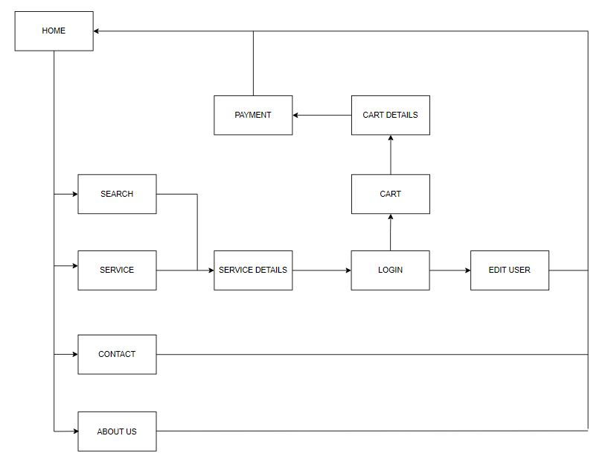

* + 1. ADMIN SITE MAP

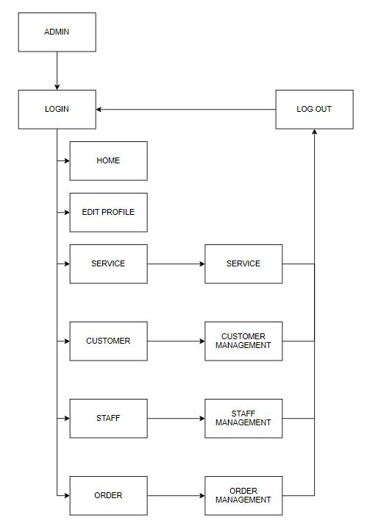

1. **GUI DESIGN**

1. CLIENT GUI

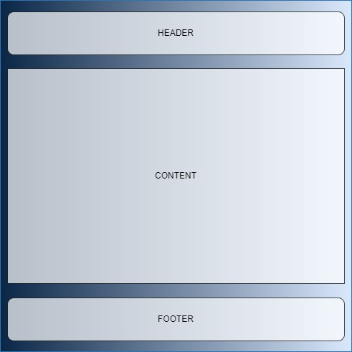

* 1. Home page (Index)

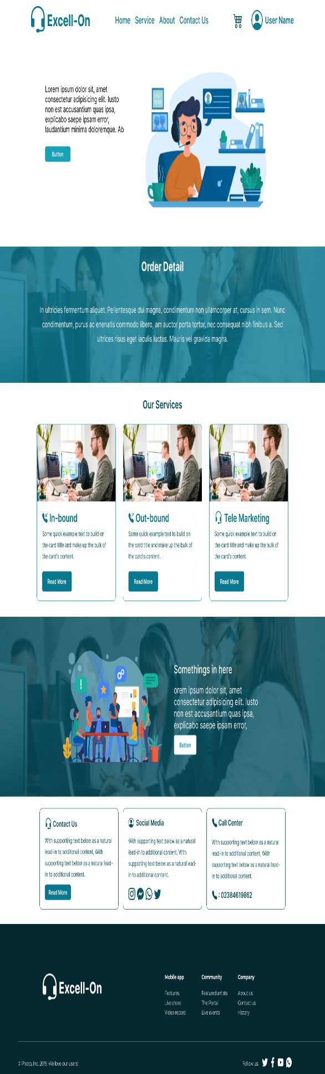

* 1. About us



* 1. Service

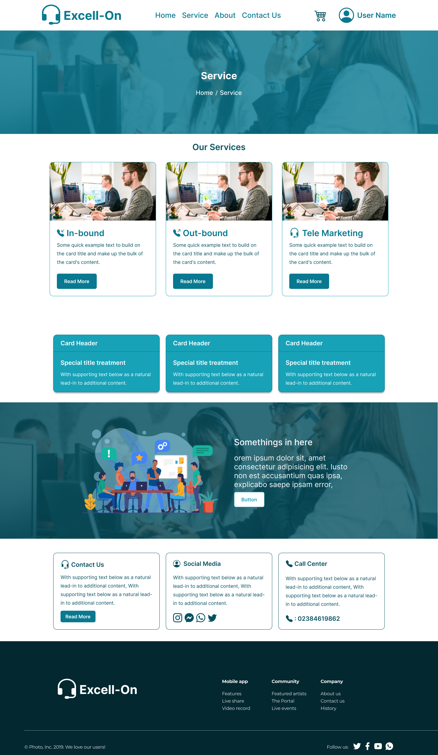

* 1. Cart

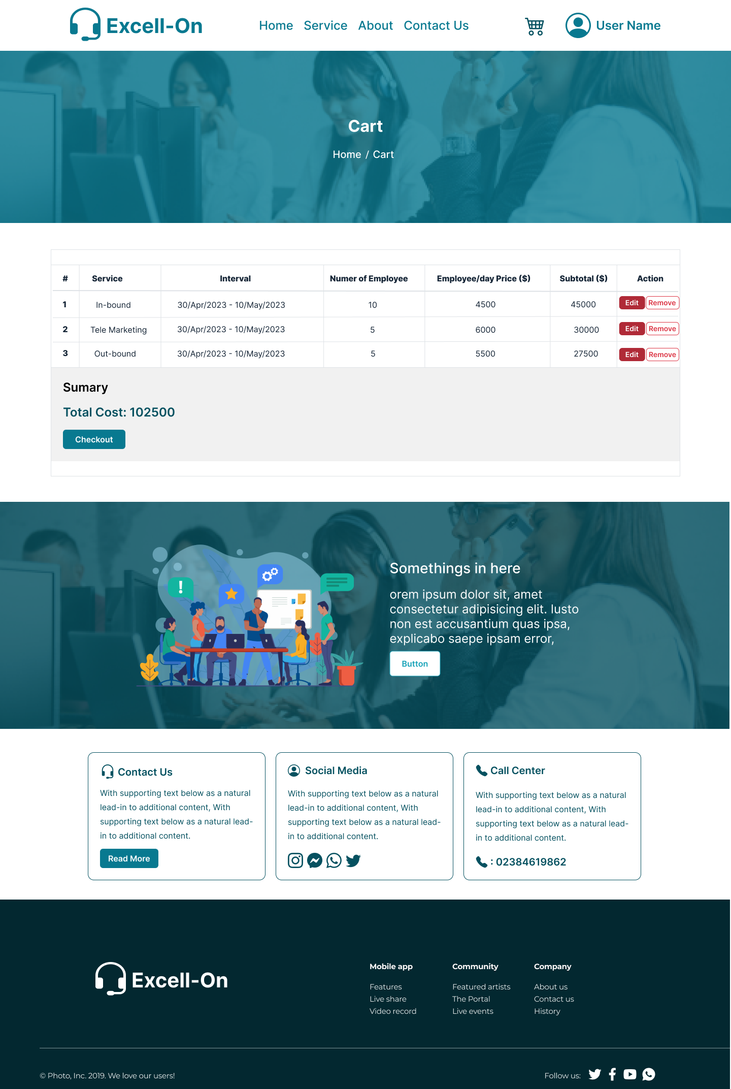

* 1. Profile

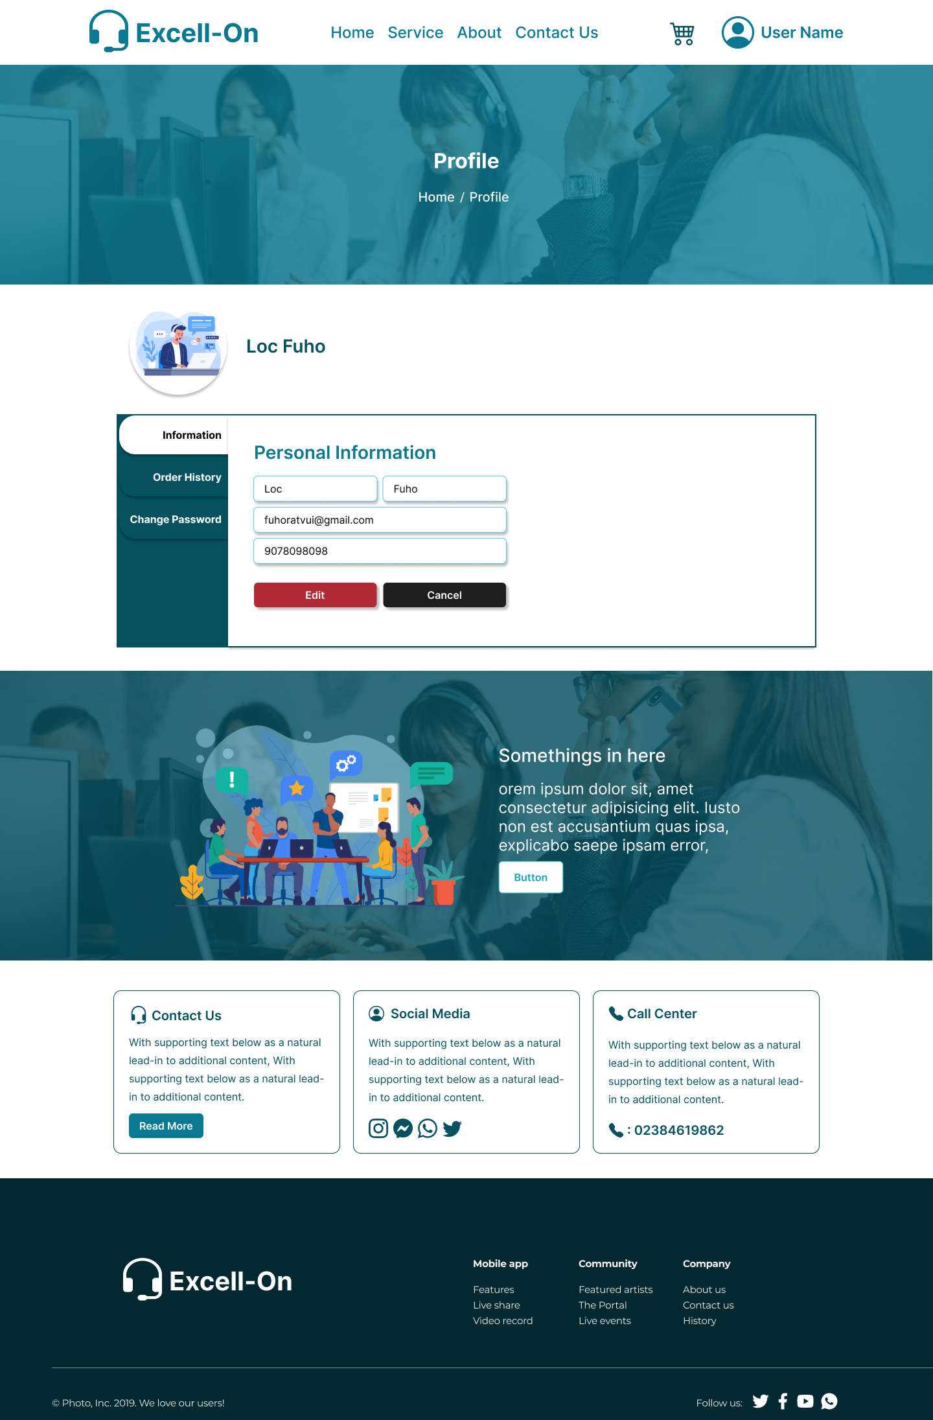

* 1. Login, Register

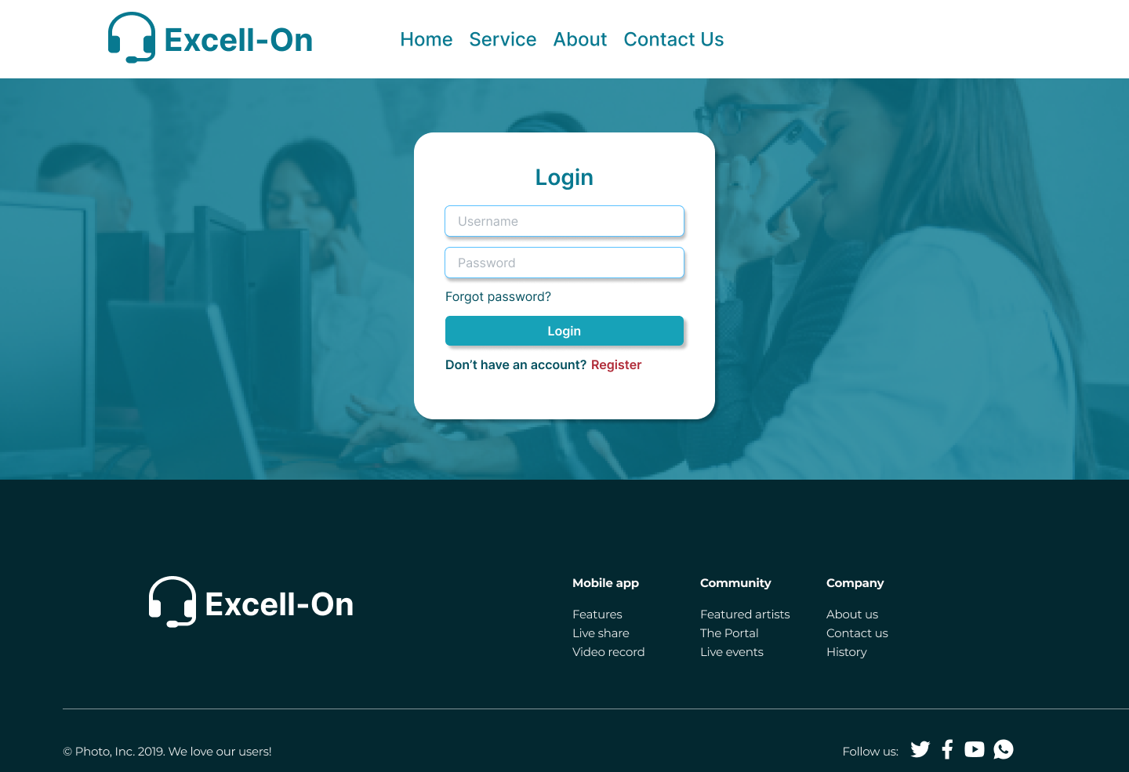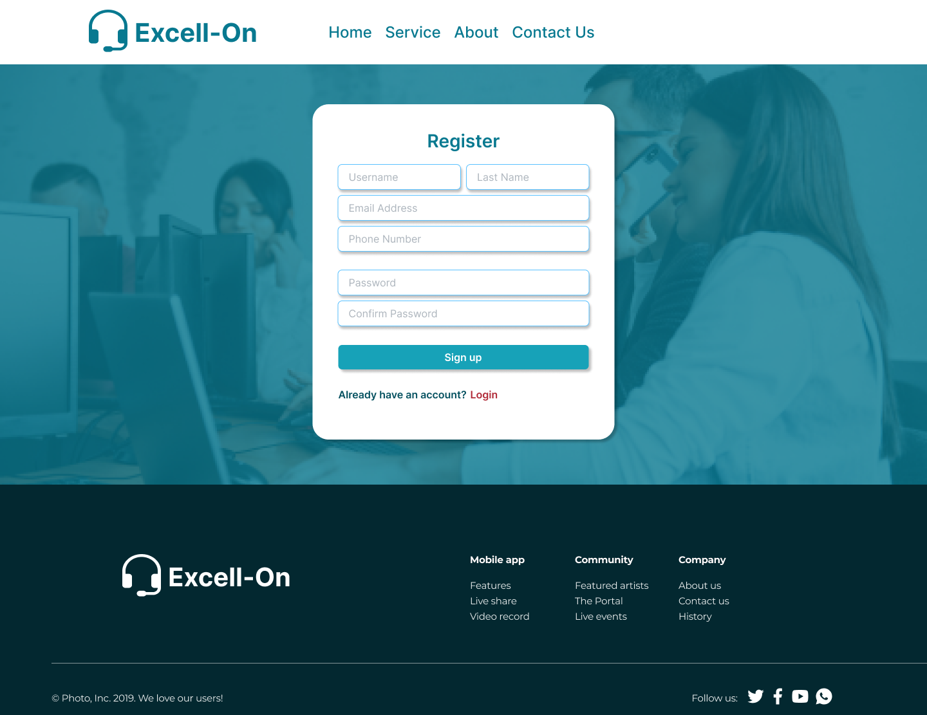

* 1. Contact

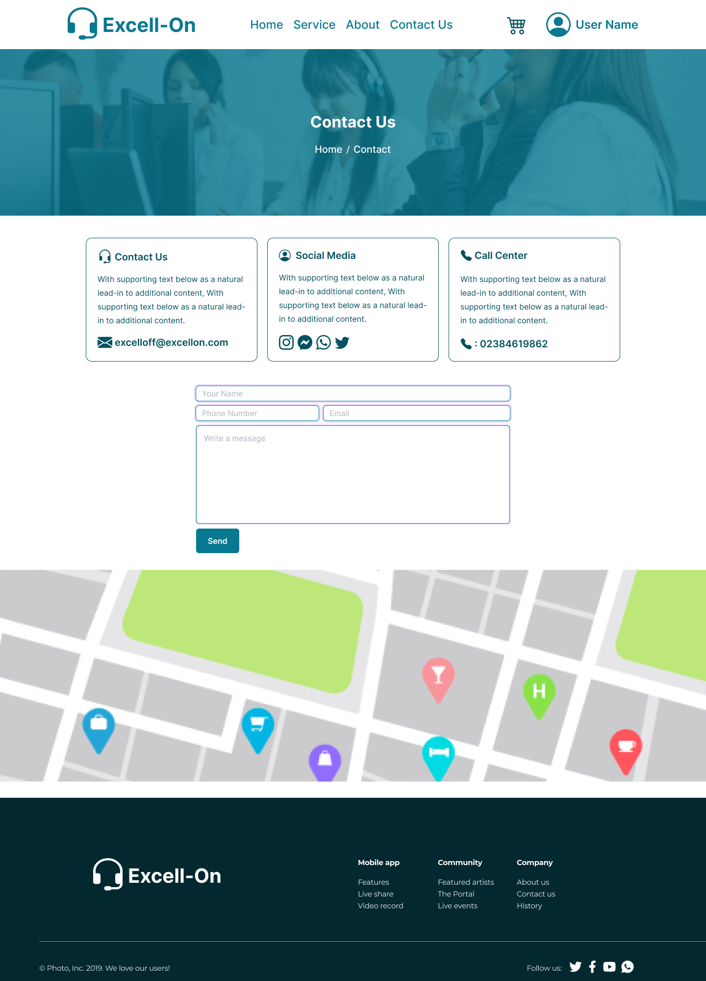

2. ADMIN GUI

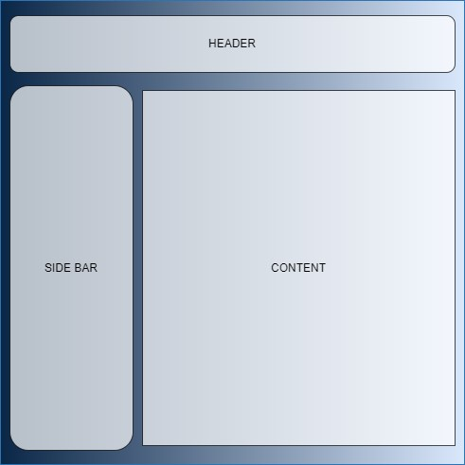

* 1. Login



* 1. Dash board

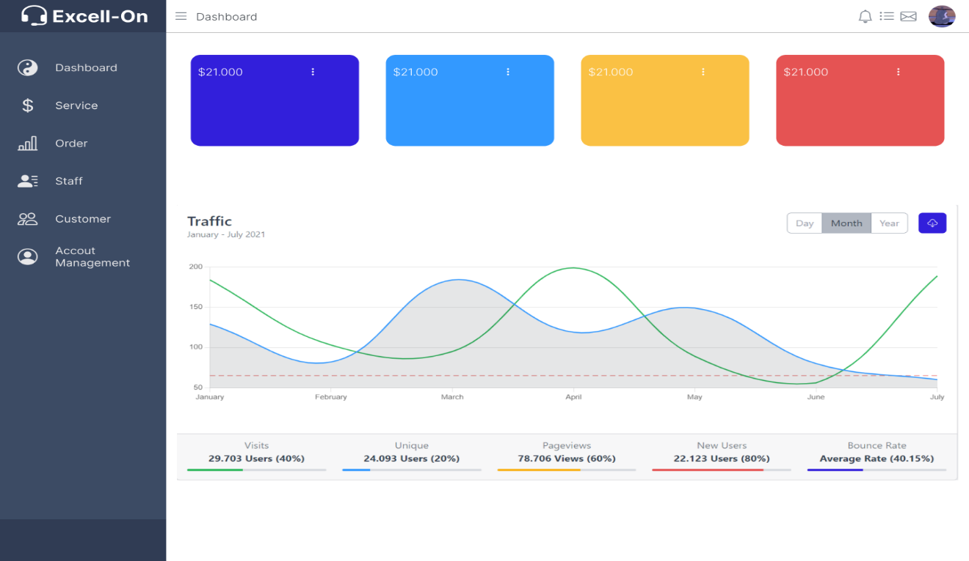

* 1. Service

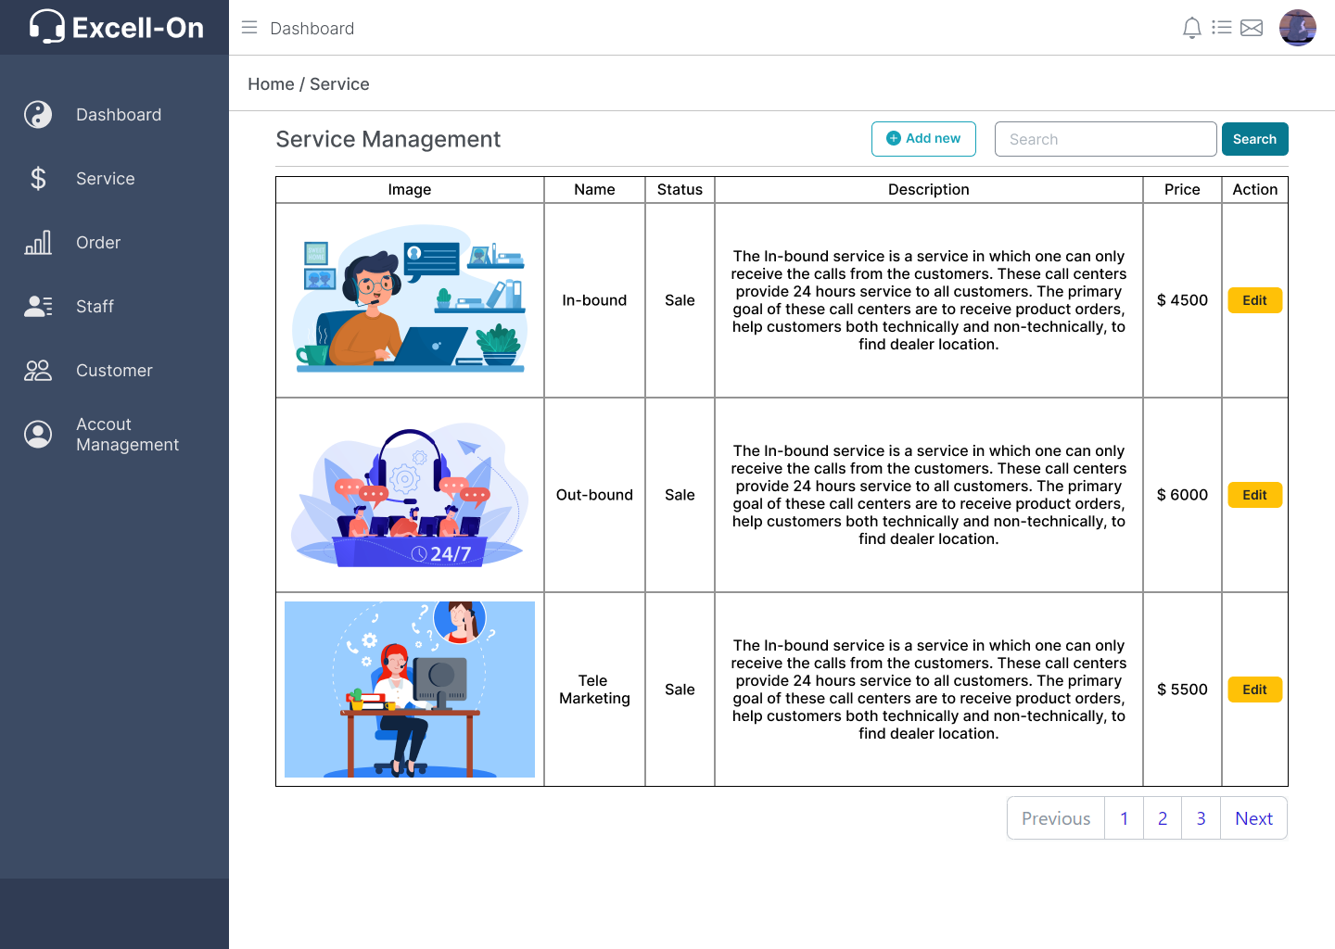

* 1. Order

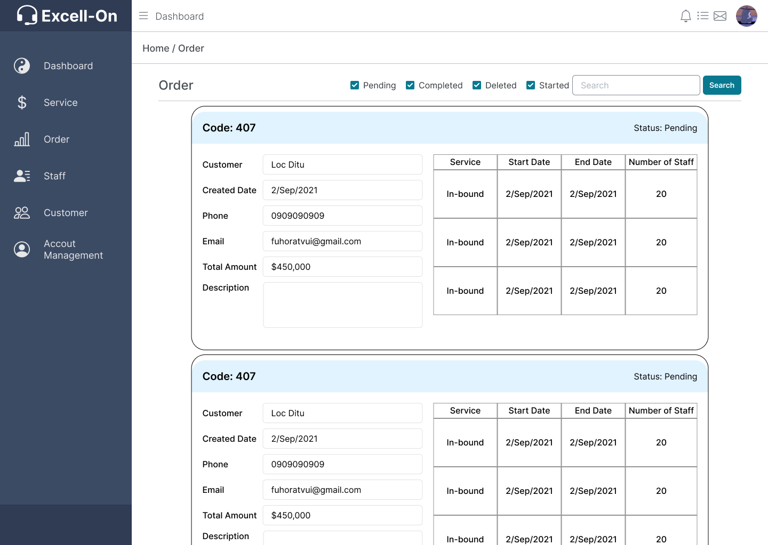

* 1. Order Detail

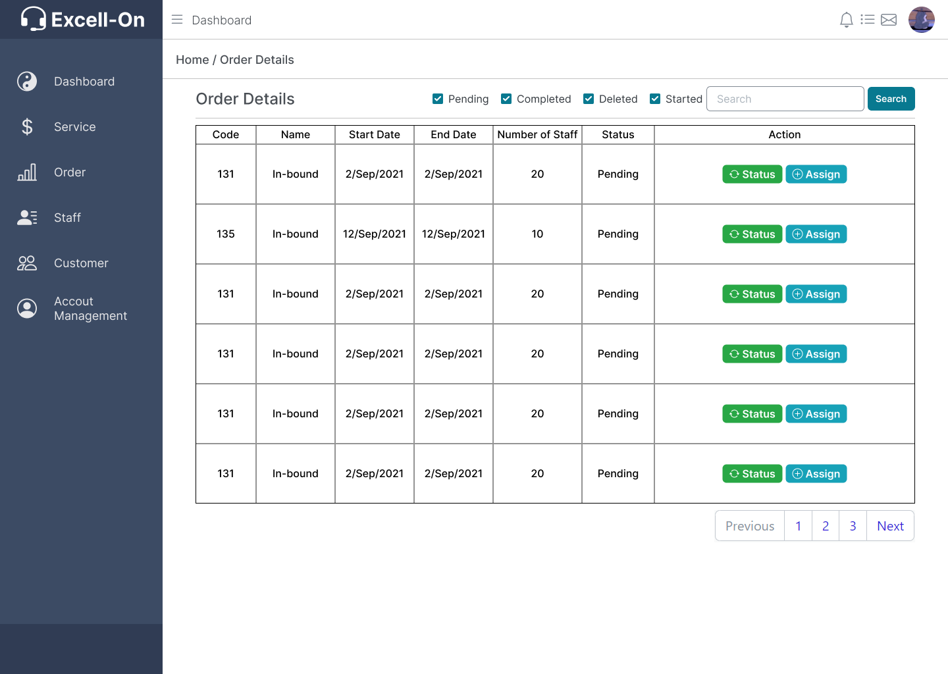

* 1. Staff

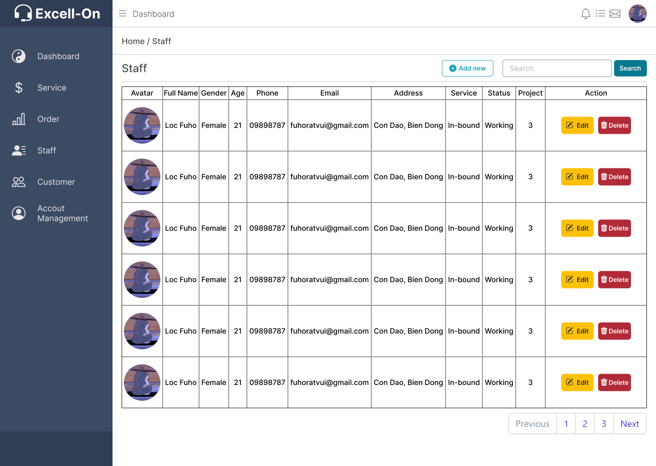

* 1. Customer

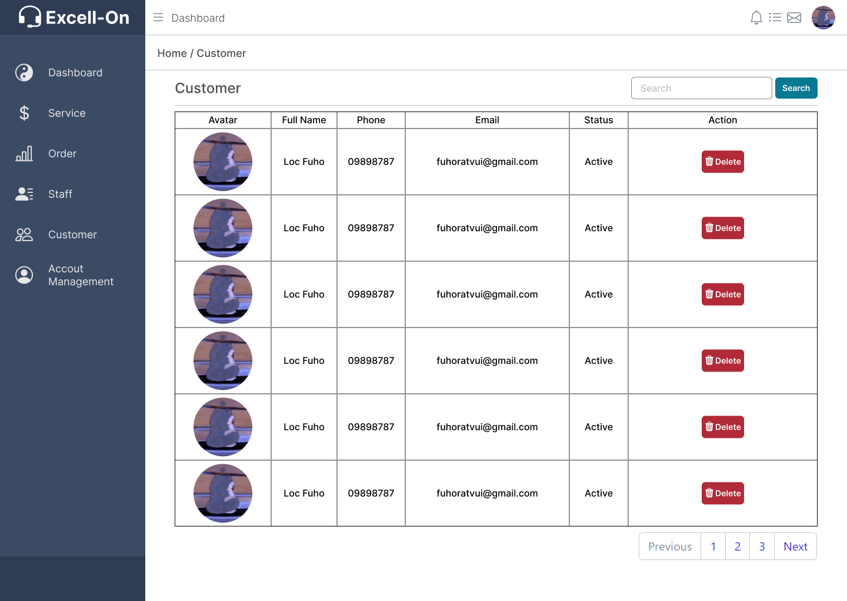

* 1. Profile

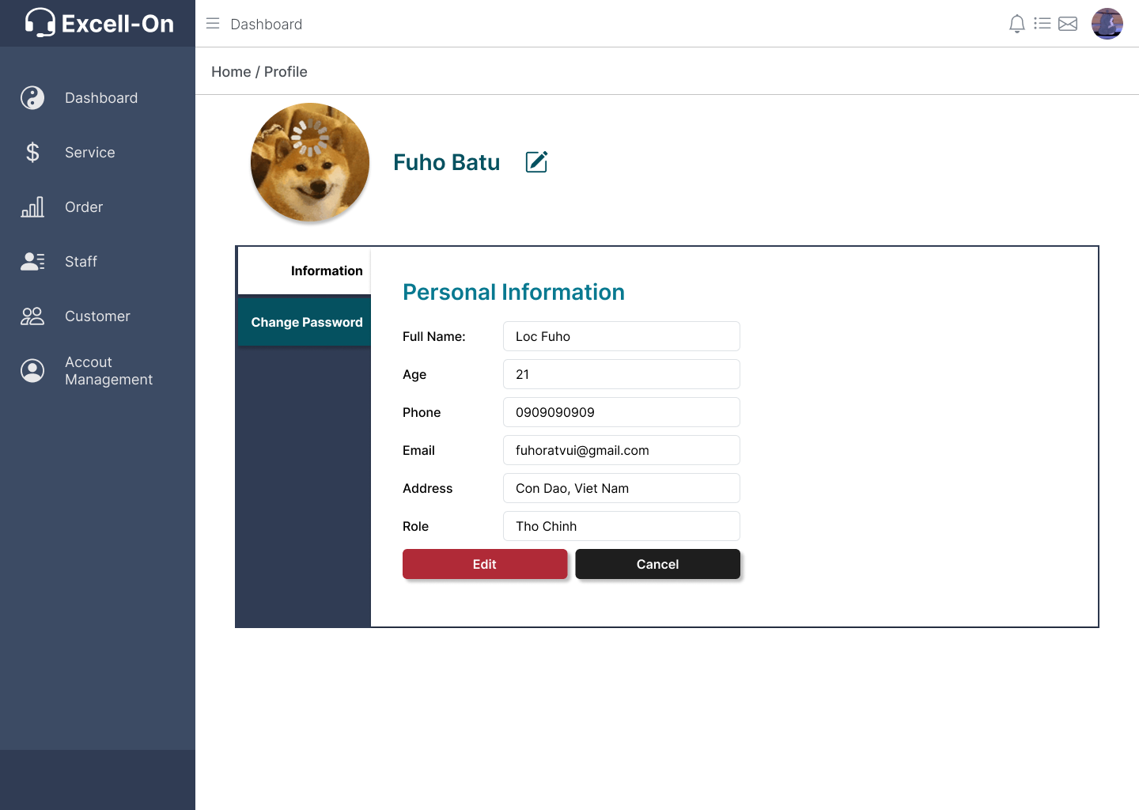

* 1. Account

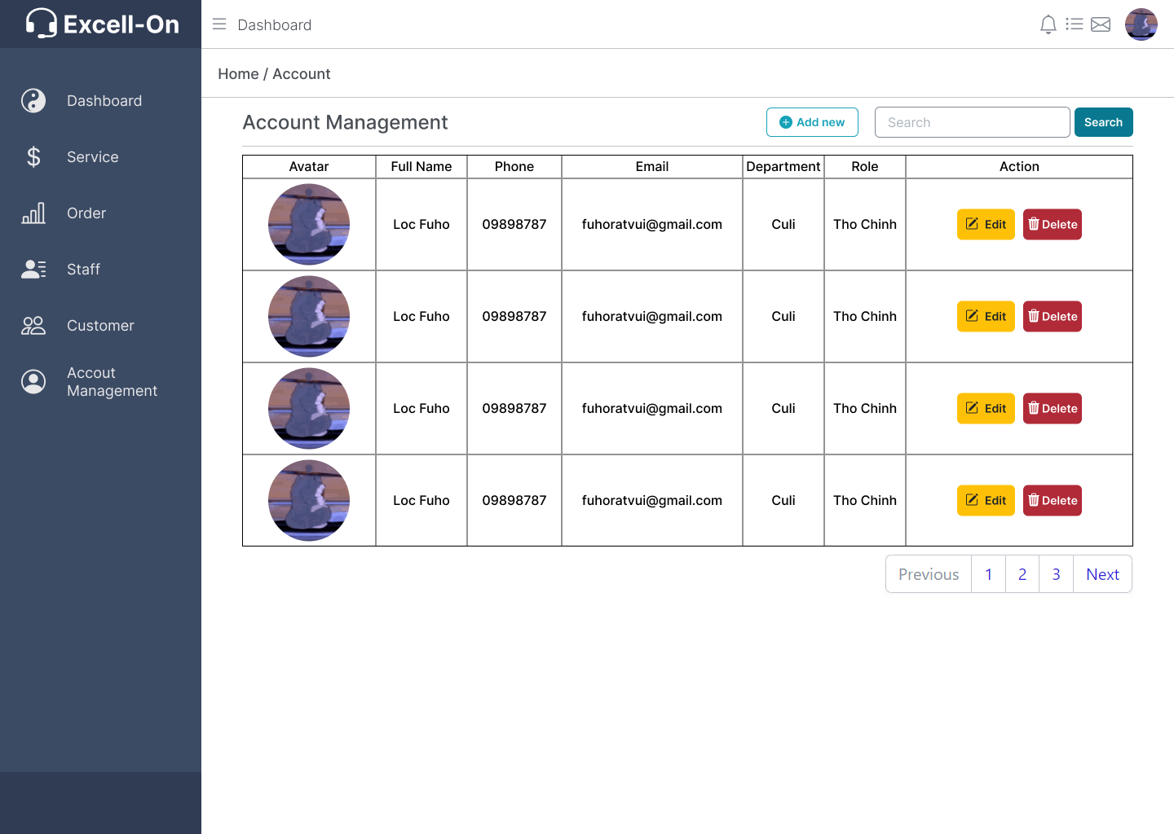

**TASK SHEET REVIEW 3**

|  |  |  |  |  |  |  |
| --- | --- | --- | --- | --- | --- | --- |
| **Project Ref. No.:**  **eP/Advertisement**  **Portal Management** **System/01** | | **Activity Plan**  **Prepare d**  **By:** | **Date of Preparation of Activity Plan:** | | | |
| **Sr**  **.N**  **o.** | **Task** | **Actual**  **Start**  **Date** | **Actual** **Days** | **Team**  **Mate**  **Names** | **Status** |
| 1 | Admin - services | All Members | 6/5/2023 | 3 | HUA QUANG | In process |
| 2 | User - services | 6/5/2023 | 3 | In process |
| 3 | Admin – Clients Detail | N/A | 1 |  |
| 4 | User – Clients Detail | N/A | 1 |  |
| 5 | Build code frames | 7/5/2023 | 4 | TUAN LOC |  |
| 6 | Admin – Employee list | 7/5/2023 | 1 | Done |
| 7 | Admin – Employee  CRUD | 7/5/2023 | 1 | Done |
| 8 | Admin – Login | 20/4/2023 | 3 | Done |
| 9 | Admin – Logout | 20/4/2023 | 1 | Done |
| 10 | Admin – Change password | 25/4/2023 | 1 | Done |
| 11 | Admin –  Authentication | 20/4/2023 | 2 | Done |
| 12 | Admin – Authorize | 25/4/2023 | 2 | Done |
| 13 | Layout | 28/4/2023 | 3 | NAM TRUNG | Ongoing |
| 14 | Admin – Order | N/A | 1 |  |
| 15 | User – Order list | N/A | 1 |  |
| 16 | User – Order detail | N/A | 1 |  |
| 17 | Admin - Testimonials | N/A | 1 | TUAN LOC |  |
| 18 | User - Testimonials | N/A | 1 |  |
| 19 | Admin – Employee  Detail |  | 1 |  |

|  |  |
| --- | --- |
| **Date: 8/5/2023** |  |
| **Signature of Instructor:**                  **Mr. Ngo Van Thuan** | **Signature of Team Leader:**                  **NGUYỄN TUẤN LỘC** |